COMSATS UNIVERSITY ISLAMBAD

5/31/2022

PAK STUDIES PROJECT

SEMESTER PROJECT

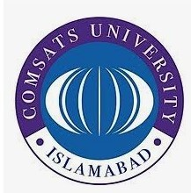ABBOTABAD CAMPUS

SYED SHAH HUSSAIN BADSHAH

(FA21-BSE-172)

QUESTION:

**CURRENT SOCIAL, ECONOMIC AND POLITICAL CHALLENGES RELATED TO INDUSTRIAL SECTOR OF PAKISTAN;**

Introduction:

Pakistan is having difficulty in facing challenges in current social, economic and politics related to industrial sectors. Pakistan’s economy hasn’t been restored since its independence. Pakistan started for the very weak industrial point and still it isn’t strong enough to help Pakistan in its industrial sector. Pakistan has not had a fruitful relation with its neighbors for a long time, its relation win Afghanistan and Iran is not very good too, and with India there have been difficulties since the day of independence, both the countries have fought many wars and especially the issue of Kashmir is the ignition between them, if the Kashmir issue is not resolved there would not be peace between Pakistan and India. Relation with china is really good, relationship between these two countries have been really good many development contracts have been signed between these two countries and also have been really supportive of each other in difficult situation economically and in wars. China has been investing in Pakistan s in industrial sector. Mainly the reason for the unsuccessful development for the industrial sector has been the wars between India and Pakistan and terrorism faced by the country on its own these factor shave deeply affected the country’s economic situation. Other factors are also involved. "Since its very inception, Pakistan's economic development has been affected by our geo-political situation: Pakistan inherited the Kashmir dispute, played a pivotal role in the Afghan War against communism alongside the very 'freedom fighters', who are now labeled terrorists and is perpetually dealing with Indian hostility since independence in 1947. In the process, Pakistan lost half its territory - East Pakistan - now Bangladesh, in1971. An additional factor now is a reported agreement between Iran and India, whereby Iran is said to have offered her territory as a safe haven in the event of a military attack against India. And now, Pakistan is a front-line ally in the war against terrorism. These wars have been basic deterrents for any investment and particularly, long-term investment in the large scale industrial sector, hence preventing sustained development.

**TOPIC:**

**Current Industrial Problems / Challenges and Solution for Pakistan:**

According to World Banks report Pakistan’s growth rate would remain negative 1 percent in the year 2020-2021. Some of the current situation that the industrial sector is facing are the following: -

* + **Political issue**
* *Terrorism*
* *Unsound policies*
* *Political insecurity*
* *International inaccessibility*

**Economic issues**

* + - * *Devaluing of currency*
      * *Underutilization of national resources*
      * *Energy crisis*
      * *Lack of infrastructure*

**Social issues**

* *Overpopulation*
* *Corruption*
* *Diseases and malnutrition*

**Administrative issues**

* *Poor law and order situation*
* *Weak criminal justice system*
* *No focus towards research*
* *Lack of development*

POLITICAL ISSUES:

Political problems could cause significant economic harm. A political challenge will lead to a regular change in policy that may have an effect on long-term economic growth plans. Political uncertainty allows development to be impaired by reducing the rate of growth in productivity. Basically, political turmoil is a shift of government or policy. Because of this issue, investors can have reservations about investing because of uncertainty.

1. **Terrorism** :

Pakistan's rise in foreign trade has been hampered by terrorism. Many multimillion-dollar corporations have been pressured to remove their holdings and assets from Pakistan. The crisis has affected many companies and many have gone bankrupt. This is a table that displays the casualties due to terrorist activities in the manufacturing sector. 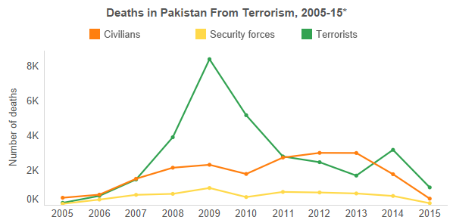

1. **Unsound policies:**

As the new government arrives after every five years, it has its own agenda and seeks to enforce it but the trouble is that due to the feud or grudge with prior government, the policy that has been made by the previous government is not given much emphasis. It is one of the under lying reasons for the political turmoil that affects Pakistan's economy in turn.

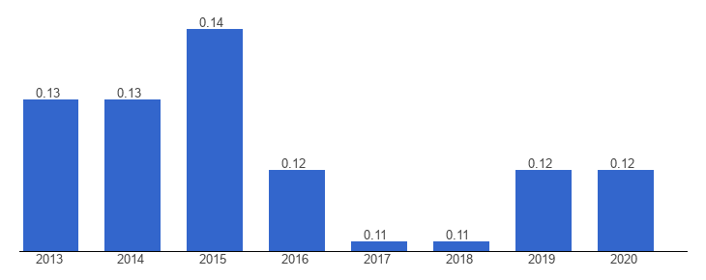

This graph shows that as the years passes the GDP decreases.

1. **Political insecurities** :

It means the same as the unsound policies that many have confusion regarding Pakistan's leadership. It's mainly because of the government's incompetence and mistrust. Because of the instability, people do not spend in areas where they fear losing their capital and the nation does not develop economically because of this.

1. **International inaccessibility:**

Pakistan, like Afghanistan, Iran and India, does not have strong relations with its neighbors. We cannot exchange goods with our neighboring countries because f the poor relationship between their neighbors, because we have to search beyond our geological zone for trade that costs more for other countries to import goods than they prefer to import from surrounding countries.

ECONOMIC ISSUES :

In the growth of the manufacturing sector, the economy is very important; it plays an important role It means that the world is going toward progress of economic growth, it means that a government will spend the tax money on the country's development. Unfortunately, the economy of Pakistan has been very weak.

1. **Devaluing of currency:**

A currency devaluation entails the downward change of the currency of nations. A poor currency, such as the Pakistani rupee, means that imports are costly and exports on the foreign market are free. As imports from Pakistan are much greater than exports, a currency devalues ​​to balance exports and imports, which is why the rupee is devalued to increase exports and decrease imports .According to the NATION:

“The value of rupee in accordance with US Dollar in December was noted as PKR 105 but kept rising until it rose to PKR 135 in October 2018. Financial experts say that Pakistani rupee might experience 5% devaluation. If counted, this is said to be the fifth devaluation since December. ”

THE NATION, Tasneem Akram, December.

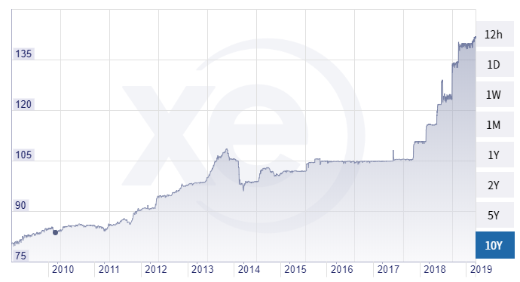

Money depreciation is often attributed to loans taken from a foreign government or loans taken from the IMF or the World Bank.

1. **Underutilization of national resources:**

The situations under which the tools in the manufacturing method are used uselessly are regarded as underutilization of national resources. Pakistan is rich in its natural resources, but unfortunately we do not have the infrastructure or the workers to operate on them. Not only does it mean that under-use is only of natural capital, but also of skilled individuals who work hard to find employment, and most of them go abroad to find jobs because they were unable to find jobs in Pakistan. The absence of the use of human capital and natural resources prevents our economy from increasing.

1. **Energy crisis:**

The energy crisis is the biggest reason for the drag on Pakistan’s economy. Pakistan have been facing this problem from the start and no measures are taken to solve this problem instead of using hydropower to create energy they are sing oil generators to produce energy. This results in load shedding and cost a lot in which the oil is imported to generate energy. Also due to the crisis of energy most of the industry could not work properly and continuously, causing the decrease in production of goods, etc. this one of the serious blows to our economy and needs to be resolved for our industrial sector to prosper.

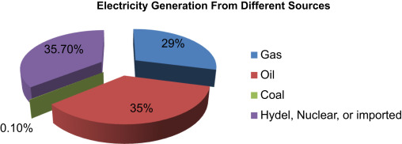

1. **Lack of infrastructure:**

Infrastructure means roads for travel, water supplies, provisions for sanitation, etc. Pakistan has no infrastructure to transport goods, which is a cheaper way to export goods. Pakistan is expected to lose about 4 to 6 percent of GDP, an estimate given by the Pakistan State Bank Infrastructure Taskforce.

"In its study,‘ Greening growth in Pakistan through transport sector reforms, 'the World Bank has said "present patterns in transport and trade logistics generate inefficiencies that are costing Pakistan's economy roughly 4-6 per cent of GDP per year," - a major constraint. The crippling energy crisis is retarding growth by 3-4 percent.

The DAWN NEWS, Khaleeq Kiani.

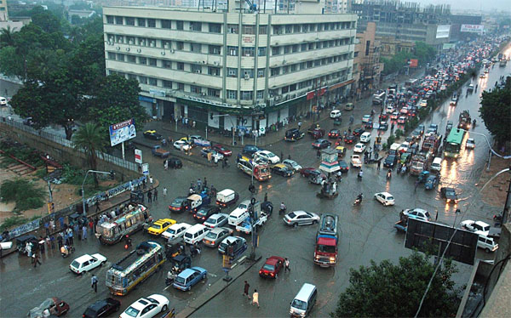

SOCIAL ISSUES:

Social challenges have been rising for a while as Pakistan’s population rises and our economy is profoundly impacted by overcrowding, unemployment, lack of jobs, cultural and religious inequality and corruption.

1. **Overpopulation:**

Overpopulation is defined as the population of a plant that exceeds its range. This is attributed to a rise in the birth rate and a reduction in the death rate. Pakistan is an overpopulated country with 212.2 million people, while Pakistan ranks fifth in the world. Overpopulation leads to hunger, food shortages due to which products must be purchased by the nation to fulfill the people's needs. Since we have to import, that means that our economy is impacted.

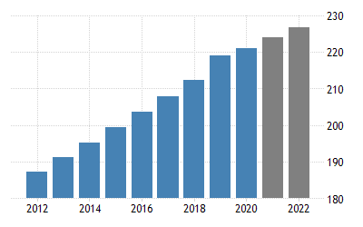

1. **Corruption:**

Corruption is a direct source of global development failure. It would decrease tax income if the tax payer does not pay his taxes and tries to deceive the government by not paying taxes. There will be insufficient funds to spend on schooling, the manufacturing sector, growth, etc. if the taxes are not charged, then the economy would fail. The corruption of not only the leadership affects the nation, even the small scale of an individual's corruption may damage the countries interest.

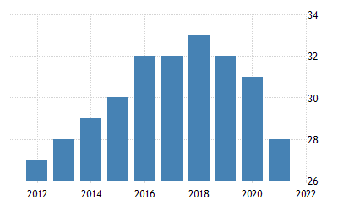

Education

The most critical topic, the challenge that will make or break the future of the

nation: education. In Pakistan, the rate of illiteracy has been exceptionally high for a

substantial period of time. Though attempts are being made to resolve this, it is still

true that much of Pakistan's schooling is not up-to-date and is thus useless

1. **Education:**

The most critical topic, the challenge that will make or break the future of the nation: education. In Pakistan, the rate of illiteracy has been exceptionally high for a substantial period of time. Though attempts are being made to resolve this, it is still true that much of Pakistan's schooling is not up-to-date and is thus useless.

1. **Diseases:**

To illustrate the impact of the disease on the economy, Covid-19 can be taken as an example. As the entire world is under a co-vid pandemic, the economies of the countries are affected and the countries that have not had a good economy are seriously affected and Pakistan is included in it. This pandemic has forced the organization and job to pause, leading to economic prosperity. Pakistan lost nearly 2.5 trillion rupees because of Covid-19 alone. Similarly, there have been multiple illnesses in Pakistan, such as dengue fever, polio, etc.

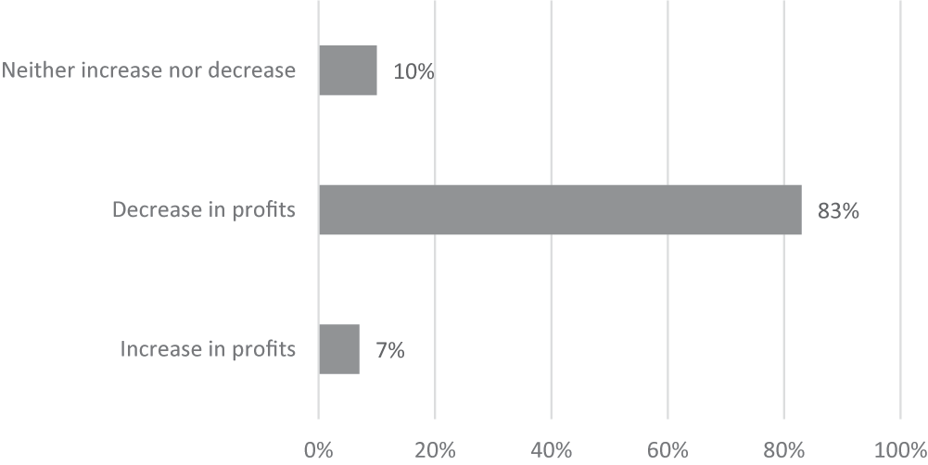

ADMINISTRATIVE ISSUES:

It has been shown in recent years that the Pakistani struggle has passed through some terrible regimes, with flawed legislation and inadequate justice structures. It seeks to enforce its own policies that influence the policies of the former government as the current government that follows after the other.

1. **Poor law and order situation:**

The economy would flourish if law and order were to run nicely. We will see arise in FDI, a much improved living lifestyle, a change in our economic conditions if there is power over law and order. Pakistan’s law and order is very poorly administered by the government, prompting investors not to invest in property protection rights due to weak security reasons. The state of law and order in Pakistan is pitiful, and there is a lack of rule of law. The principle of justice of all under the law is not monitored and the upper class cheats the government by corruption, etc., through the acts of their criminal activities.

1. **No focus towards research:**

Many have studied the absence of study in Pakistan over the years. In academic foundations, too the condition is sometimes debated. In both of these claims, the shortage of resources and proper infrastructure are presented as the key reasons for the lack of study in the country on a sufficiently wide scale. If the developing country is noticed for its good results in research, others would invest because they want good manpower.

SOLUTIONS TO THE CURRENT SOCIAL, ECONOMIC AND POLITICALCHALLENGES RELATED TO INDUSTRIAL SECTOR OF PAKISTAN:

Keeping the current state of Pakistan in view, and the fact that Pakistan has not been able to lift itself up towards prosperity in over 70 years since its creation, the solutions to the issues mentioned above will neither be attained easily nor quickly. Patience and perseverance are key if the nation is to be uplifted from its sorry state. Below are the steps mentioned which must be taken into account if the solutions are to be provided.

POLITICAL ISSUES:

With the ever-changing and unstable political environment of Pakistan, the political issues may require the most effort to be resolved.

1. **Terrorism:**

Widely known as a terrorist nation because of this very issue, the eradication of it is apriority. This issue has the potential to be resolved in a shorter period of time and perhaps permanently, if the appropriate steps are taken. The armed forces will have to play a great role, one that they have been playing for some time now. The support, whether moral or financial, will be required of the citizens.

1. **Unsound policies:**

The incompetence and illiteracy of the policy makers of the country must either be educated, or replaced altogether. Their improper decision making, in the economic or political sector, has already led to major losses, as mentioned above.

1. **Political insecurities:**

The unstable nature of the political landscape must be tamed. Only then will foreign investors feel safe and compelled to invest in a country which otherwise has such potential.

1. **International inaccessibility:**

The foreign disputes of the nation, which have been dragging on since the nation’s birth, must be settled and settled quickly. The country must let go of old grudges and give way to new friendships and profitable connections. Relations especially with the neighboring countries must be settled as a priority.

ECONOMIC ISSUES:

The economy makes or breaks a country; that much is evident. The industrial sector heavily depends on a stable and thriving economy to flourish.

1. **Devaluing of currency:**

The country must focus on increasing its exports by increasing production and utilizing whatever available resources and talent the country possesses. Only then will the exports surpass the imports and the value of the nation’s currency will rise. Imports must also be limited unless necessary.

1. **Underutilization of national resources:**

Pakistan is a gifted state with a huge variety and quantity of natural resources, and most of it remains unused and is being wasted away. That must be put to an end and the required staff and machinery must be brought into work to utilize these resources to their fullest. The industry will benefit tremendously from this.

1. **Energy crisis:**

One of the major issues that affects Pakistan, it is high time that the energy crisis put to an end. A huge amount of potential Hydro-energy is being wasted, same goes with the abundantly available fossil fuels which lay under the rich soils of Pakistan. Their utilization is a priority if this issue is to be resolved.

1. **Lack of infrastructure:**

Although extensive work is being done in this field, still much is yet to be accomplished and the government must not let loose when it comes to building infrastructure, which not only helps the local industries tremendously but the exports of the nation will also benefit from this.

SOCIAL ISSUES:

Pakistan suffers terribly from these issues. Such issues are perhaps at the core of all issues, and must be treated accordingly.

1. **Overpopulation:**

Overpopulation is becoming a threat to Pakistan, as the rapid increase over the past few decades indicates. This must be controlled by educating the people over the harms of overpopulation and how it affects the nation as a whole. In a country where people are already suffering heavily from malnutrition, poverty, disease and homelessness, it is a top priority to put a cap on the rapidly increasing population of the country.

1. **Corruption:**

The root of all evils, eradication of this social issue is the most difficult of all. The change required is not of the government or the people, but ourselves, the individuals. Only then will this evil, which has been running in our veins from generations, will be eradicated. The individuals must take this crucial step, correcting themselves, then their close ones, the society and finally the nation as a whole.

1. **Education:**

The whole sub-continent has suffered from this issue greatly. Illiteracy rates still reign high in Pakistan. The introduction of proper, easily available and fruitful education must be introduced in this country before yet another generation suffers from it. This is only possible with the increased allocation of budget towards the education sector, along with the introduction of literate and competent management.

1. **Diseases:**

As the recent Covid-19 has declared, Pakistan needs much work in the health sector. Hospitals, clinics and capable doctors and much needed in Pakistan, but the country seems to lack of all of these. An appropriate health budget, along with the appropriate management, can lead to the solution of this issue.

ADMINISTRATIVE ISSUES:

To sum up in a few words, the administration of Pakistan is as incompetent and useless and impractical as they come. Below are a couple of administrative issues which need immediate attention.

1. **Poor law and order situation:**

Pakistan has the capacity to make new laws, but never to implement them. That is not to say that the laws made in the first place were adequate, but even good efforts seem to go to waste as there is no enforcement of these laws. The government needs to get a strict hold of their management and citizens in order to efficiently administer their laws for the benefit of the nation as a whole.

1. **No focus towards research:**

The constant repeating of old ideas and methods has left Pakistan far behind economically and in other spheres as well. This must change. Pakistan’s government should allow room for change and perhaps even encourage it, as to grow forward.

**CONCLUSION:**

Pakistan suffers from a tremendous amount of issues in all aspects of its existence. However, countries have risen from the ashes in far lesser time and even came to be successful in the modern world. Examples such as China, Japan and even India, should be an encouraging force to drive Pakistan forward. These issues can be eradicated, step by step, as the nation unites towards a common purpose; the prospering of the nation as a whole.

**THE END**